Digital Logic Design

Summer STEM 2020

The Cooper Union

***Week 2.1 Problem Set:* NE555P *Timer***

Problem 1:

We’ve been introduced to the **NE555P** timer; let’s see how we can adjust the parameters R1, R2, and C to get different periods, frequencies and duty cycles.

The **NE555P** timer is wired up like so:

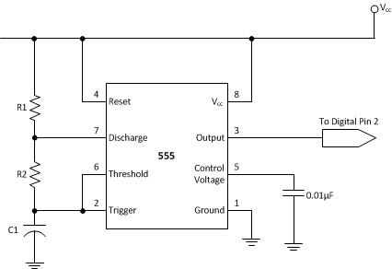

1. Your DLD Summer STEM kits have 68 µF capacitors and 430 Ω, 470 Ω, 10 kΩ and 100kΩ resistors. Using [ohmslawcalculator.com/555-astable-calculator,](http://www.ohmslawcalculator.com/555-astable-calculator) look at how the different combinations affect the period, frequency and duty cycle of the **555**.
   1. Find a combination that gives a frequency below 1 Hz.
      1. **2 10kΩ**
   2. Find a combination that gives a frequency that is near 1 Hz.
      1. 470Ω and 10kΩ
   3. Find a combination that gives a frequency above 1 Hz.
      1. 2 470Ω

1. Use parameters R1 = 470 Ω, R2 = 10 kΩ and C = 68 µF. *Reset each time.*
   1. Increase C to 680 µF, then decrease it to 6 µF. What happens?
      1. . Increase capacitor = longer period
   2. Increase R1 to 47000 Ω, to decrease it to 4 Ω. What happens?
      1. . Decrease resistor = faster

iii. Increase R2 to 100000 Ω, to decrease it to 10 Ω. What happens?

Answers are at the bottom of the calculator’s page.

1. Bonus: play with [houseofjeff.com/555-timer-oscillator-frequency-calculator](https://houseofjeff.com/555-timer-oscillator-frequency-calculator/)

1

Digital Logic Design

Summer STEM 2020

The Cooper Union

Problem 2:

There’s a more useful schematic of how to wire the **555** timer that annotates the chip like you would see it.

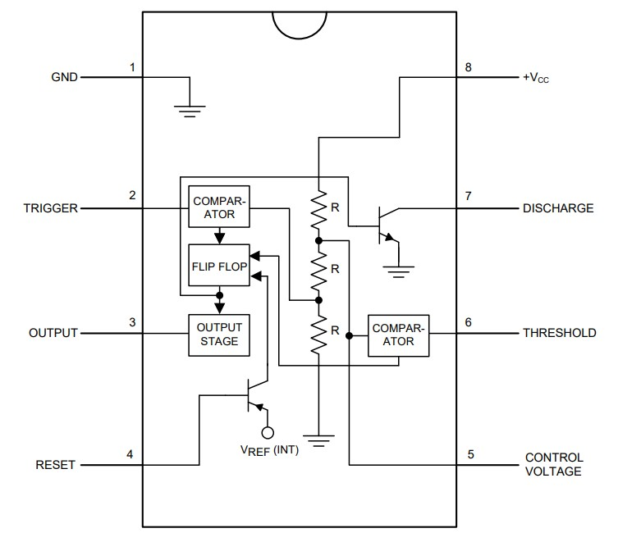

1. Use TinkerCAD Circuits to build a 1 Hz, ~50% duty cycle **555** timer.
   1. Blink a LED to display the clock signal. Don’t forget the capacitor on pin 5.
   2. Confirm with your instructor before moving on.
2. Next: build a clock with the **NE555P** chip!
   1. Use any breadboard, but it maybe be useful to use the small breadboards. Don’t forget a current limiting resistor before your LED.
   2. Take a video and save it!

Tips:

* Good work starts with showing your work!
* Don’t be afraid to ask for help!
  + Consult your classmates and instructors if you get stuck.
  + Inform the instruction team if you have computer issues
* Follow good practices while breadboarding

2